Ayesha Zubair
52916
Compiler Construction
Lab 4

Task 1: atleast 1 zero
Code:
#include<iostream>
#include<string>
using namespace std;

int main()
{
string input;
cin>>input;

int state=0;

for(int i=0;i<input.length();i++)
{
char c=input[i];

if (state==0)
{
if(c=='0')
state=1;

else
state=0;
}

}
if (state == 1)
cout << "Accepted";
else
cout << "Rejected";

return 0;
}

Output:
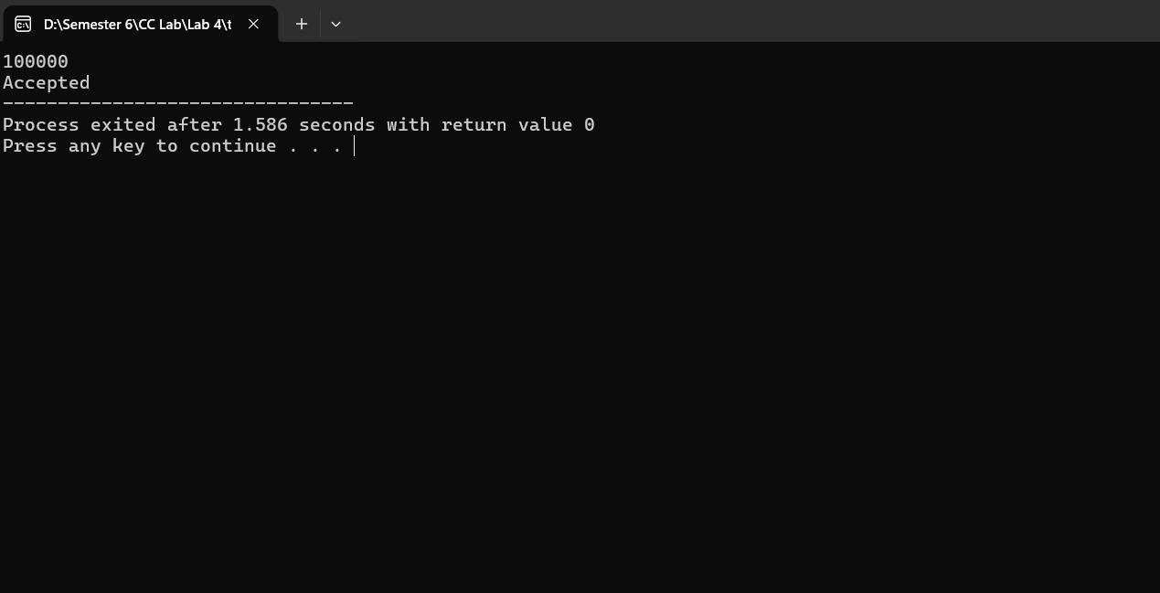
Task 2: start with 1, end with 0
Code:
#include<iostream>
#include<string>
using namespace std;

int main()
{
string input;
cin >> input;

int state = 0;

for(int i = 0; i < input.length(); i++)
{
char c = input[i];

if(state == 0)
{

if(c == '1')
state = 1;
else
state = 3;
}
else if(state == 1)
{
if(c == '0')
state = 2;
else
state = 1;
}
else if(state == 2)
{
if(c == '0')
state = 2;
else
state = 1;
}
else if(state == 3)
{
state = 3;
}
}

if(state == 2)
cout << "Accepted";
else
cout << "Rejected";

return 0;
}
Output:
